**INDIAN WASTE MANAGEMENT:CONNECTING THE DOTS**

Abhishek Sharma   
3rd year Civil Engineering  
IIT KharagpurKharagpur-West Bengal

[abhisheksharma5490@gmail.com](mailto:abhisheksharma5490@gmail.com)

Archit Chaudhary  
2nd-year Mechanical Engineering  
MNNIT Allahabad Prayagraj -Uttar Pradesh thexcalibur7@gmail.com

Amisha Agarwal  
2nd-year Electronics And Communication Engineering  
MNNIT Allahabad Prayagraj -Uttar Pradesh [amishaagarwal1998@gmail.com](mailto:amishaagarwal1998@gmail.com)

Bhuvan Jhamb  
2nd year mechanical engineering  
MNNITAllahabad Prayagraj -Uttar Pradesh bhuvanjhamb29@gmail.com

Keshari Nath Tiwari  
2nd-year Electronics And Communication Engineering  
MNNIT Allahabad Prayagraj -Uttar Pradesh [keshari0601@gmail.com](mailto:keshari0601@gmail.com)

**ABSTRACT**

India is the world's 2nd most populated nation. With a still increasing population, the waste generated is also increasing. And management of this huge amount of waste is really a herculean task. The present garbage management models have not been successful despite huge investment from the government. This paper presents a method for proper management of this waste for a cleaner, healthier and more prosperous nation. A statistical analysis of how waste can be used for income generation has also been presented. This paper includes an innovation in present garbage bins linking them with technology to fulfil the aim of a clean India. The fault in the present system has also been highlighted and it has been attempted to provide a solution to the same. A case study of garbage management models of other nations has been included and comparison has been drawn with respect to their feasibility in our country. A better model for garbage collection and treatment has also been presented.

**INTRODUCTION**

Waste management is amongst the most serious problems faced by India today. A great garbage menace can be attributed to rapid industrialization and population explosion, especially in developing countries.

India houses almost 3 million truck-loads of untreated waste. If these trucks are laid end-to-end, it will equal to half the distance from the earth to the moon, or rather 15 trips from Mumbai-Los Angeles, says an India Spend analysis. (1)

Unscientific handling of waste causes an adverse impact not only on all components of the environment but also on the economy and human health. The present measures despite spending massive amounts are providing no significant results. The cities of India produce 100,000 tons of solid waste daily. The government spends from 500 to 1,500 rupees per ton of waste. This means 5 crore to 15 crore rupees are spent on waste management daily. 60-70 per cent of this amount is spent on garbage collection, up to 30 per cent more on transportation, and only the remaining approximately five per cent is spent on recycling,”(2)

The need for waste management is growing day by day. The incessant burning of dry leaves causes air pollution and infertility in the soil. Dumping of waste in water bodies adversely affects aquatic life. The infamous examples include the Ganges and Yamuna rivers. Nearly half of Yamuna river has been declared dead. Organic waste if utilized properly is of high value. With a population growing at a phenomenal rate, it is time that the maximum conservation policy is adopted. A normal solid waste management plan would generally follow the following procedure:

Major aspects of waste management include

1)setting targets for actions required

2)identifying budget requirements

3)identifying & coordinating with the stakeholders to achieve the targets vi. arriving at a rational basis for setting up a waste processing /disposal facility

4)Harnessing right tools for mass awareness(3)

Generators are needed to segregate waste into three streams, Wet (Biodegradable),Dry (Plastic, Paper, metal, wood, etc.), domestic wastes (diapers, napkins, empty containers of cleaning agents, mosquito repellents, etc.) and handover segregated wastes to authorized rag-pickers or waste collectors or local bodies (Solid Waste Management Rules 2016)

But this has not been put much into practice. Segregation of waste is very necessary prior to recycling. Segregation means sorting and separate storage of various components of solid waste namely biodegradable wastes including agriculture and dairy waste, non-biodegradable wastes including recyclable waste, non-recyclable combustible waste, sanitary waste, and non-recyclable inert waste, domestic hazardous wastes and construction and demolition wastes. (Solid Waste Management Rules 2016)

This paper deals with the proper analysis of waste problem scenario in India, highlighting the reasons why existing solutions are inefficient and also discusses G-Dump, a concept that combines technology, business, and design and is not only an effective solution to manage garbage but also converts it into a useful product. We have the design to ensure segregation at the root level, a user-friendly, highly efficient and eco-friendly technology which also highly pays the user for their garbage.

**BACKGROUND**

India produces 62m tonnes of urban waste annually, out of which 5.6m tonnes consist of plastic waste, 0.17m tonnes constitute of biomedical waste, 7.90m tonnes constitute hazardous waste while 15 lakh ton is e-waste. The total waste generation is estimated 165 million tonnes by 2030. 43m tonnes is the total amount of solid waste, out of which only 11.9m tonnes are treated while 31m tonnes are untreated and dumped at landfill sites.

Studies reveal that India discards around 0.6 m tonnes of plastic waste into oceans annually. It has been ranked as 12th in producing plastic waste and has been ranked as 10th for generation of municipal solid waste. It is 5th in generating e-waste. (7)

Most businesses define waste as “anything that does not create value”(4).In a common man’s eye, anything that is unwanted or not useful is garbage or waste. However scientifically speaking there is no waste as such in the world(5). Almost all the components of solid waste have some potential if, converted or treated in a scientific manner. Proper management not only leads to reuse of the so-called waste but can also lead to revenue generation.

Our government is trying hard and spending a huge amount but still desired results have not been achieved. It is a very common sight to see people littering garbage 100 m away from the dustbins. Even day to day household waste is not taken proper care of. With more and more open space becoming the site of dumping the locality’s household waste, there is necessarily something wrong in how the public considers the waste problem of our country. It is important to provide incentives to people to manage their waste. So a people-centric efficient process is needed and that is G Dump which does exactly the same by providing cash rewards on proper waste disposal. In the world of technology, environmental problems are solved in the best way by technical solutions.

With dustbins that sense garbage and provide cash rewards, the attitude of people towards waste handling can be positively changed. Segregation is ensured at the time of disposal itself. Solid waste Management having proper segregation and scientific recycling of all the components, seems to be the perfect way of waste management.

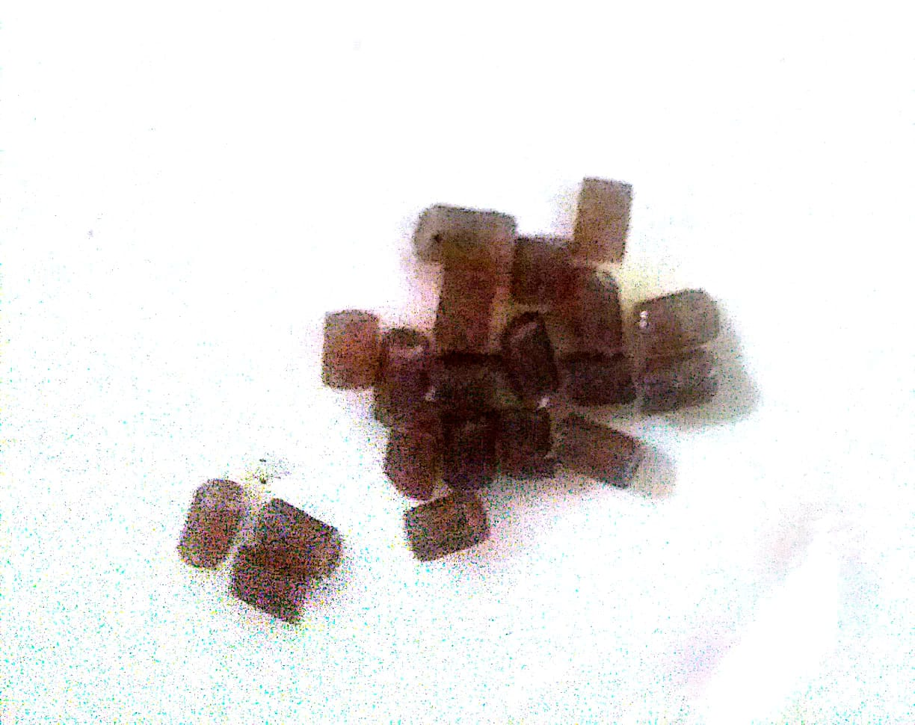

Plastic in pellet(daana) form.

FICCI research paper 2017

**IDEOLOGY:**

Despite huge investment on cleanliness, expected results have not been achieved. The existing models failed to produce expected results because they were process-centric and neglected the people aspect of it. With campaigns like "Swachh Bharat" the Indian govt. has undoubtedly tried to involve people but no innovation was included in the process. Creating awareness among people is important but not sufficient. In Lucknow bhandaras, in spite of having enough public dustbins and repeated warnings to use them, the public did not use them and littered garbage all around.

It must be realized that the 100m Gap between user and dustbin can only be compensated if they are tempted to use bins by providing them with proper incentives. This is exactly what G Dump does.

G Dump not only collects their garbage but also pays them for it and this has been made possible by use of IOT and advanced technology. Garbage sensing, waste segregation, and code generation are important aspects of this project.

**METHODOLOGY:**

G Dump is a concept of scientific waste management by proper integration of technology business and design.

Two ways to collect and manage our waste are provided by G Dump.

a)The G Dump Public Dustbin:

The main components of the dustbin are:-

1. Pedal bin(mild steel)

2. Resistors

3. LDR(Light Dependent Resistor)

4. LCD(Liquid crystal Display)

5. Atmega328(Integrated Circuit)

6. Laser diode

7. Plane mirrors (3 inches X 2 inches)

This design of the dustbin is unique as it detects waste when thrown in it with the help of our sensor-mirror arrangement. When the pedal of the bin is pressed laser light is emitted.The light after multiple reflections from plane mirrors at an angle of 45 degrees from the normal reaches the LDR.The purpose of the mirrors is to cover maximum cross section of the dustbin.The resistance of an LDR increases with the decrease in intensity of light falling on it. When the user throws garbage in the bin it blocks the passage of light and hence the light intensity decreases and the current decreases. This change in current is read by the IC- Atmega328, which enables the LCD to print the code on the LCD screen.

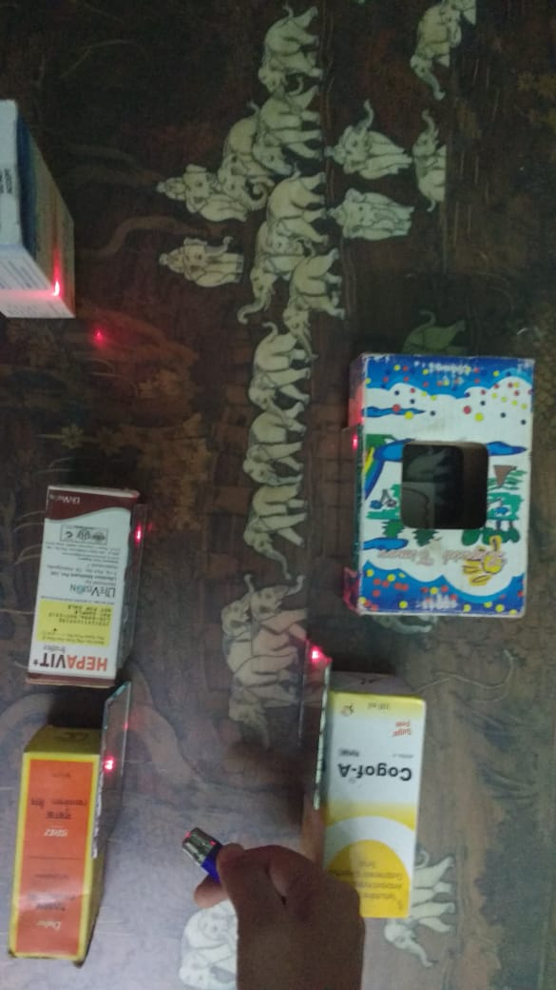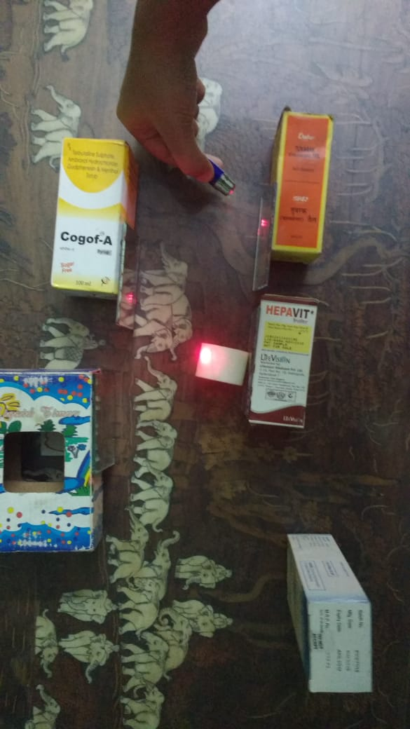

**The pictures show the path of laser before and after the garbage has been placed in the pa**t**h**.

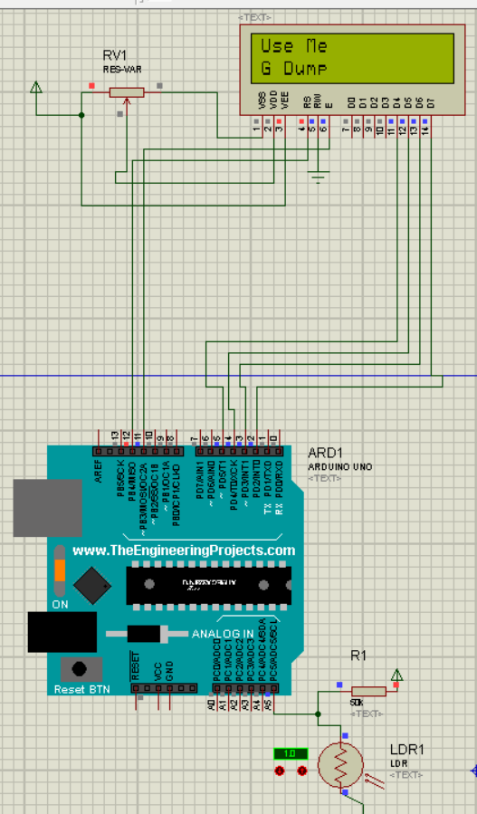

The picture shows a simulation of the circuit for one chamber of the bin before garbage is thrown into it.

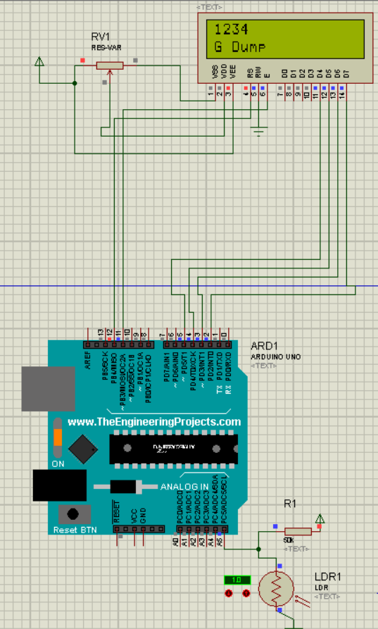

Simulation of circuit for one chamber of the bin after garbage is thrown into it.(Code is generated)

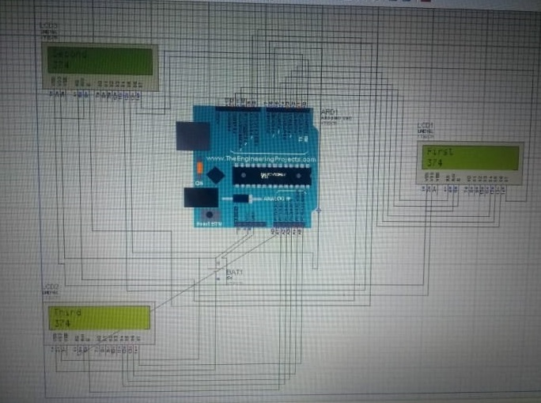

**A proteus simulation of the circuit showing the working of the bin for a 3-chambered dustbin**

After successful code generation, the code is entered in the G-Dump mobile app. Malpractices like fraud code submission are taken care of. The foot pedal serves as the switch to trigger the circuit ON thus consuming minimum energy. The 5 chambered dustbin ensures segregation at time of disposal itself into biodegradable, soft plastic, hard plastic, e-waste, and metal waste and other miscellaneous waste. The cavity of the bin is 50 cm in length and 50 cm in breadth while being 150 cm deep. All the segregation sections are differently coloured.

This collection and segregation system ensures proper recycling for optimum changes.

b)Home collection system:

Dustbins with demarcated columns for waste segregation will be provided to people. Collection of segregated waste from homes and its proper treatment ensures maximum utilization. Through proper incentives and cash rewards, the country’s biggest problem can be solved.

**The Gdump App**

The code users get from bin will be submitted on an android application. The code will then be checked that whether it is actually a code or a fake string. To utilize the features of this app, the user has to authenticate himself (for the first time). Authentication can be done via a phone number, through a Facebook ID or an email address. After authentication, a profile of user will be created and he would be able to fill up the code each time he uses the bin. The user would get some fixed points each time he uses the bin. If the user wins he will be notified. There will be prizes after every 1000 points earned by the user. There is a help section in the application for queries. The application is designed to work on nearly every Android phone.

**CASE STUDY**

INDORE MODEL

Topping Indian government’s Swachh Survekshan survey that aims to measure the degree of cleanliness in Indian cities for the second year in a row, Indore in Madhya Pradesh offers a curious case study.

The following features were observed to be key features of Indore garbage model:

DOOR To DOOR(D2D) COLLECTION SYSTEM:

Everyday garbage is collected twice (i.e Morning and Evening). Along with the vehicle two sanitary workers and one volunteer from respective NGO are allotted for an area that covers 1,000HH. Each householder segregates the garbage (i.e Dry and Wet) into two separate dustbins and dumps it. When the vehicle enters in the area a unique song will be played. The stakeholders come and hand over the garbage to the worker. The NGO volunteer maintains the garbage collection record, interacts with the householders, notes any specific issues, and creates awareness among the public. As per the route map, the vehicle moves around the ward.

People are supposed to pay a Rs.60/-per month for collection of garbage along with their property tax. They were satisfied with the collection of the garbage. If there is any function in that area, they inform to the volunteer of the NGO/Sanitary staff, and a separate vehicle is organized for that purpose. They also undertook certain measures to ensure proper management, such as

* For IEC activities and community mobilization purpose, they engaged five Non-Governmental Organizations and allotted the areas for them.
* Wall writings are covered in the major junctions of the city and Govt. Building/office boundary walls with slogans to create awareness.
* They utilized a single color background in entire sanitation activities example: collection van, monitoring jeep, the background of the wall writings only single colour yellow, so this colour was very attractive.
* They established both infrastructure and built up effective human resources as they prepared a strategy for improvement of sanitation.
* They imposed the fines on the violator.
* They arranged twin bins on the main roads in commercial areas every 40 meters.
* Sufficient vehicles are with them and involvement of NGOs/corporators to monitor the activities.
* Each vehicle fixed the GPS system, they easy to monitor the vehicles from the call centre.
* All the municipal staff was fulfilling their responsibilities within the timelines, they also doing dedicatedly for improvement of the ULB.
* There are cooperation and support between Higher Authorities and Grass root level workers in all aspects
* The Municipal Commissioner involves all line departments in his strategy: a) He wants police support for enforcement b) Jurisdiction intervention for implementing the policies and rules/Acts c) Mayor and Commissioner had good understanding d) District Administration supports in all interventions e) Identified the public expectations and given the prioritization on that gaps.
* Plastic recycling unit was established, this was maintained by the NGO
* Issued the ID cards to Rag Pickers in the city (nearly 3200 members in the city
* Innovatively established the unit for flower recycling in the city: They collect all flowers from the temples and recycled the compost to reuse for the purpose of the plantation.
* In construction areas the builder/owner should provide the toilets to the workers, otherwise, they will not issue the building plan approval
* Each vehicle should maintain the dustbin in the vehicle (Govt transport/public vehicles)
* There should be one dustbin every 400 meters on Major roads.
* A Door to Door waste collection and segregation ▪ Evening cleaning and waste collection from commercial areas ▪ Biometric attendance and GPS monitoring of vehicles ▪ Mechanized road sweeping ▪ Waste collection from bulk generators by a separate system ▪ Litter picking along roads and open area/plots ▪ Collection of construction and demolition debris
* Establishment of Modern Transfer Station ▪ Scientific Waste Processing ▪ Engineered Landfill ▪ Establishment and operation of small composting units ▪ Establishment and operation of OWC composting system ▪ Plastic waste collection and processing unit ▪ Extensive IEBC activities through NGOs and PR agencies ▪ Other allied activities related to swachhta such as Nala cleaning, footpath, rotaries and left turns..(6)

**CONCLUSION**

In this paper, we presented our innovation in the waste management process. We identified that the existing measures are process-centric whereas we need a people-centric efficient process. Hence we presented the idea of G-Dump, which consists of innovation in the waste segregation and collection process. With this smart idea the general public will be tempted to use our dustbins which will lead to a cleaner nation. A detailed analysis of plastic recycling will ensure more quantitative recycling after the segregation process. The wet waste is in itself a resource as it produces methane gas and manure. The sources of revenue generation have been briefly and it has been observed that overall huge profit is possible with achieving the target of a clean India.

**REFERENCES:**

(1)-The great Indian urban waste problem: facts... | Development Channel

(2)-Is It Possible to Clean up India? — BRICS Business Magazine

(3)-International Research Journal of Engineering and Technology (IRJET)

(4)-Waste management initiatives in India

(5)-5715-16631-1-PB | Waste Management | Municipal Solid Waste

(6)Source(SWACHH SURVEKSHAN 2017)

(7)http://www.developmentchannel.org/2017/08/27/